DataBase Backup From Live Server to Backup Server

It’s a shell script Database backup tool, which work by run this script.
This script run by :
./create_backup_db.sh -u 'postgres' -p 'nobodyisshaon' -s 'public' -d 'hr'
here we use 4 type of flags which are use in live server:
-u assign postgreSQL user name
-p assign postgreSQL user password
-s assign Database schema name
-d assign Database name

When run this script, It take a Backup according to flags.
This script mainly complete 3 task for LIVE server,
and 1 task for Backup server

I) create DB backup to target folder. Like /home/test_server/AGL_DATABASE_BACKUP/Databases/
backup file named as Dbname-date-time.dump
hr-12-06-2022_10-18-15.dump
dump file are encrypted.
II) create DB-backup info as log file. Which contain detail information of DB backup On Separate folder. Like
/home/test_server/AGL_DATABASE_BACKUP/DataBaseLogs/
DB-backup log file named as Dbname-date-time.log
hr-12-06-2022_10-18-15.log
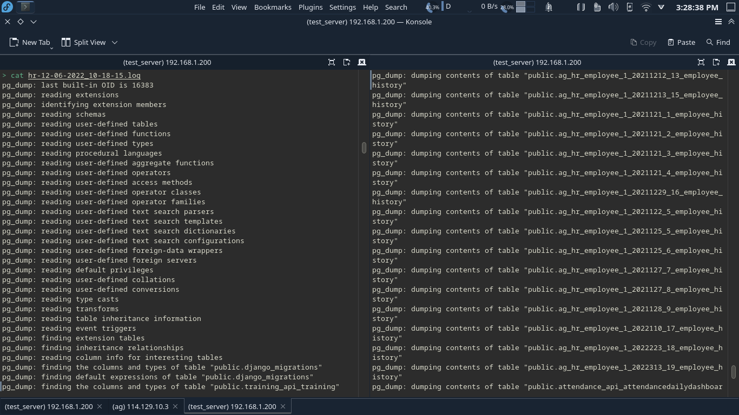

III) transfer file from live server to local server using Secure copy protocol (SCP).

IV) create DB-backup transfer info from live to backup server as log file. Like
/home/test_server/AGL_DATABASE_BACKUP/DatabaseTransperLogs
DB-backup transfer info log file name as
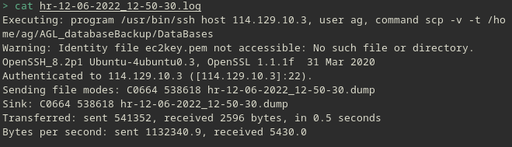
hr-12-06-2022_12-50-30.log

This script worked as automation by corntab.

this script run automation in 2 cases.
I) if server restart
@reboot /var/www/backend/restartScript/create_backup_db.sh -u 'postgres' -p 'nobodyisshaon' -s 'public' -d 'hr'
II) if it’s 12am o’clock
0 0 * * * /var/www/backend/restartScript/create_backup_db.sh -u 'postgres' -p 'nobodyisshaon' -s 'public' -d 'hr'

